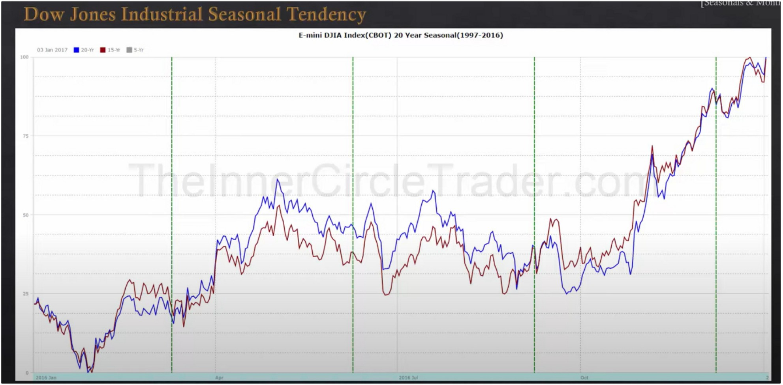**Seasonals & Monthly Swings**

SP500 is a more accurate picture of what the stock market is doing Theres 3 divisions in a year for stock trading

First half of the year theres generally going to be a lot of magnitude with a lot of volatility to 1 direction, generally its going to be bullish

the second portion of the year is the last quarter of the year and thats generally a bullish time of the year as well, its because its filled with holidays and year end spending has to come in so thats going to cause a lot of energy. A lot more volacity at which it goes higher in contrast to the first part of the year

The most critical part of the year is the middle, low magnitude period. Begins in may and ends in october. Its a lot less directionally driven markets, that doesnt mean you wont have short term directional biases and or opportunities, but if youre going to be trading then do less leverage and a lot less activity. Generally you want to be looking for a range bound consolidation period in these times. By month theyre still going to have individual seasonal tendencies, but primarily focus on being a trader from october to end of the year and from february to may



**O)Jan1U** ■**20-ff** ■**n-w** ■ **.'ff**

**E-mini OJlA lndcx(COOT} 20 Vear Scasonal(l997-2016)**

**Low Magnitude Period**

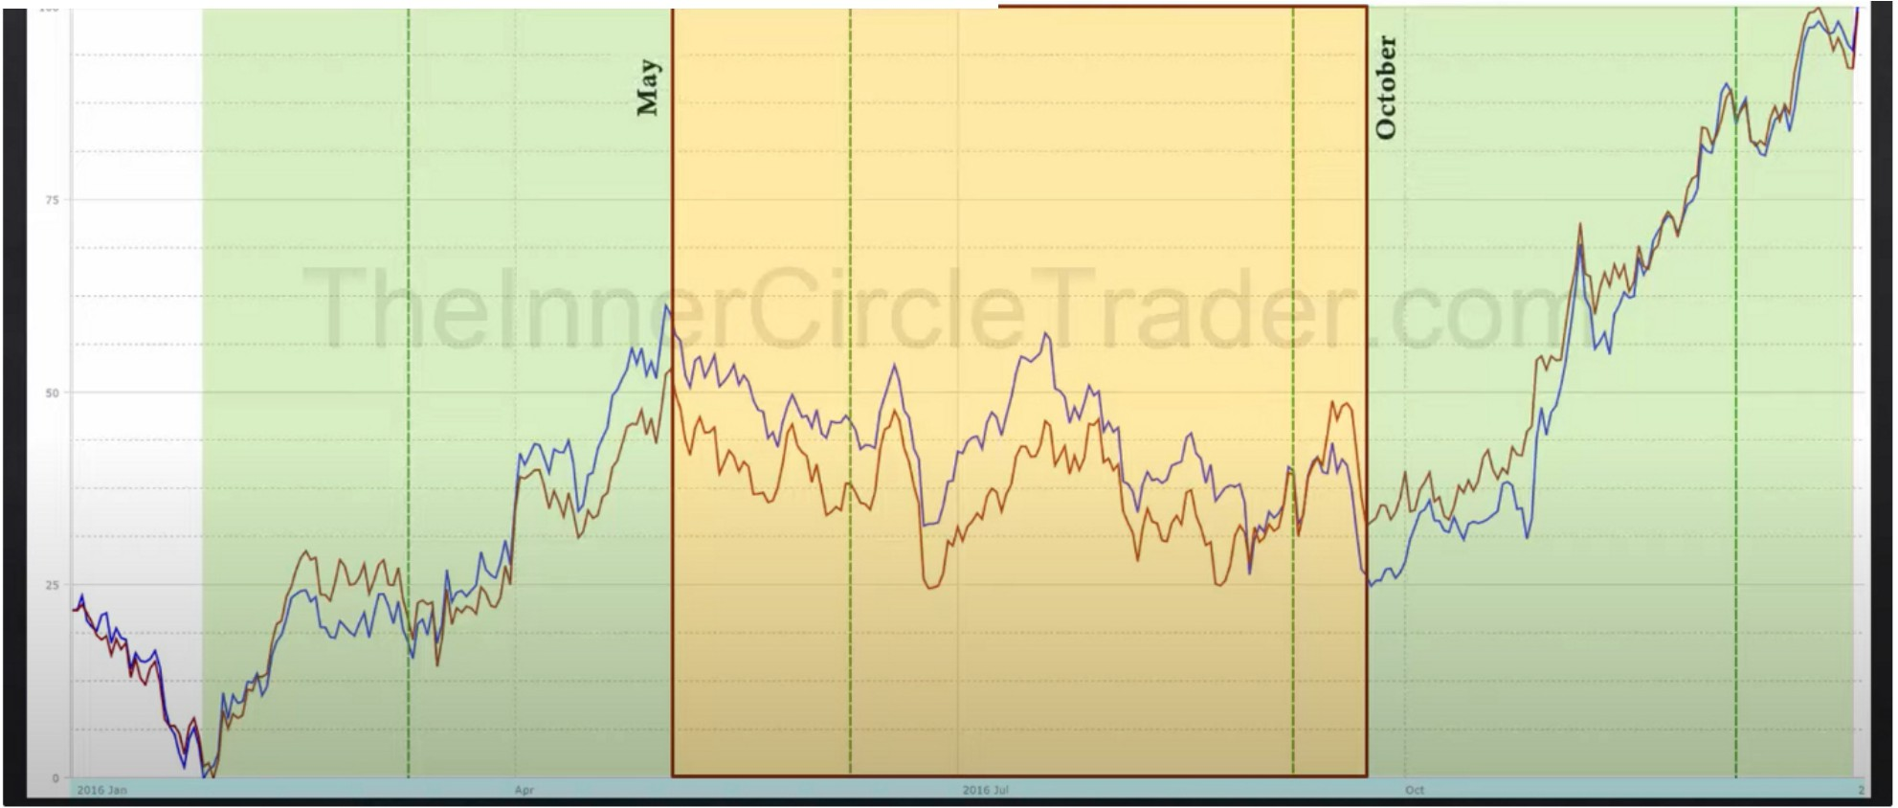

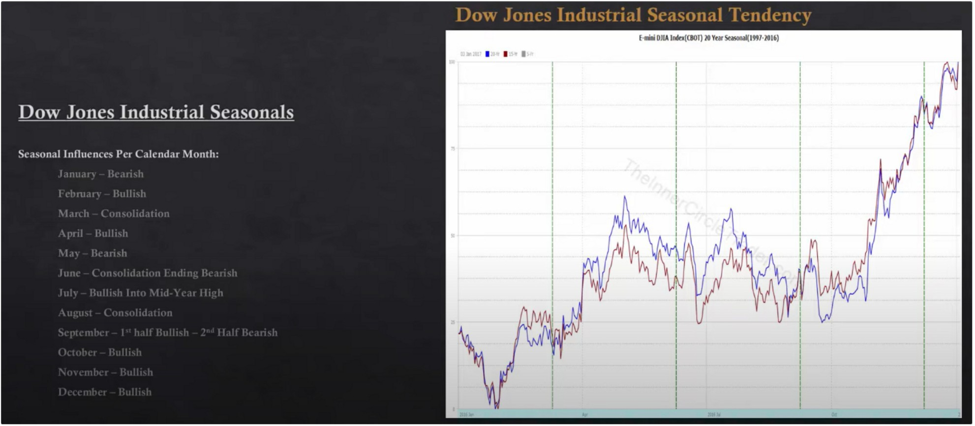

The low in october can happen in then 2nd half of september also, 1 of these months is likely to make a seasonal low and then trade aggressively higher

If we see the red and blue line aligned, that adds confidence to the tendency This is great to know for swing trading etc and even day trading

Lower probability months: March, June and August. Not high probability conditions generally

Its obviously not always going ot be the exact case, but generally and over a long term view it is

If there are bearish months like january or may and were in a bear market that could then be translated in a super bearish month like supercharged short selling

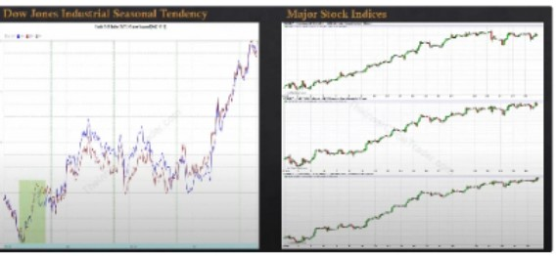

February

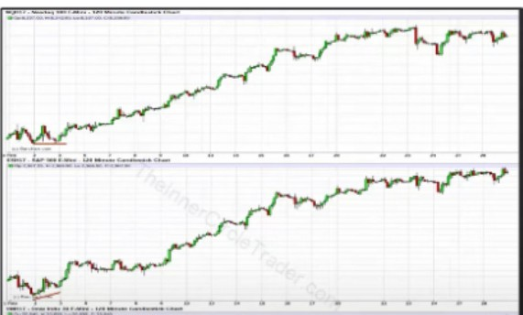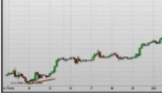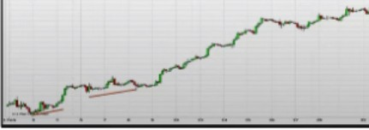

/

? ---•--• •-•• M • •

•••••

\

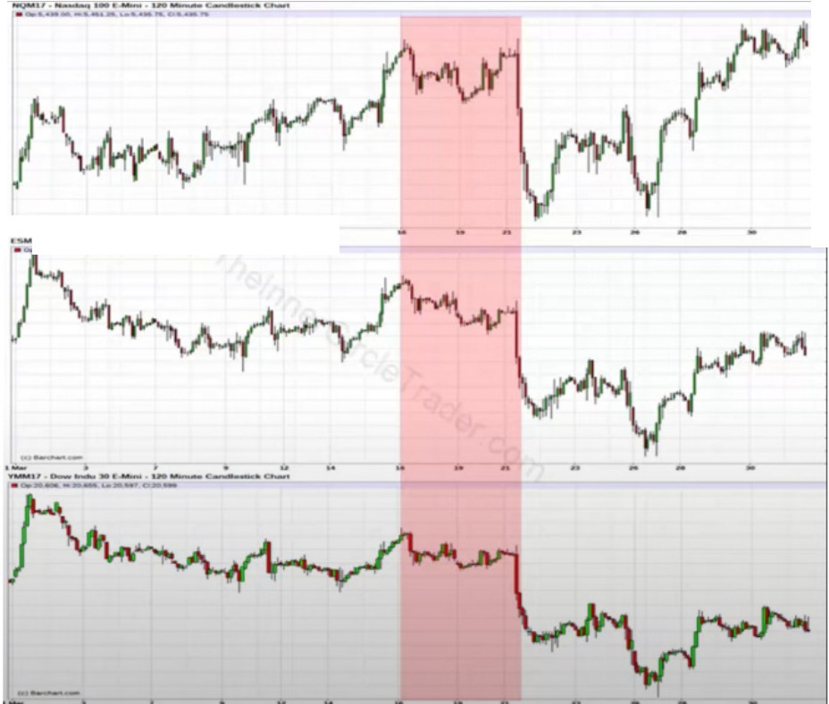

*,..:· --*

..-.-..-;.:-=-=-- .,_ .. ..

*i ,V'*

March, J· ust because its•a •

doesnt mean th . consolidation

eres isnt any opportunities

April

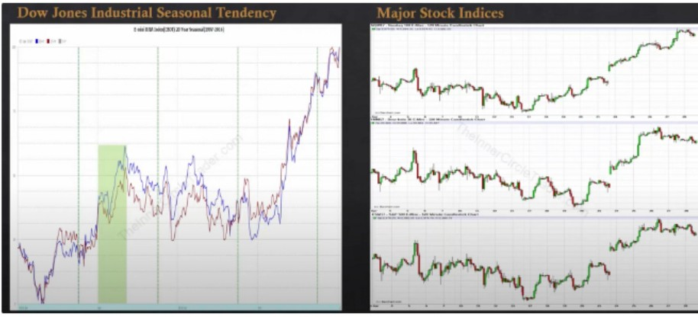

*J*·. *'*

- - - - .. - ..

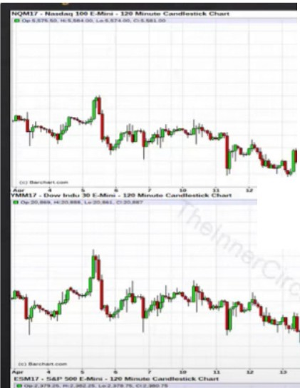

-

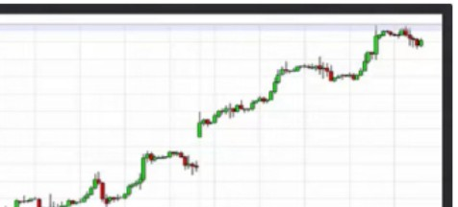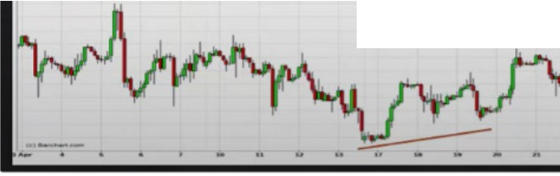

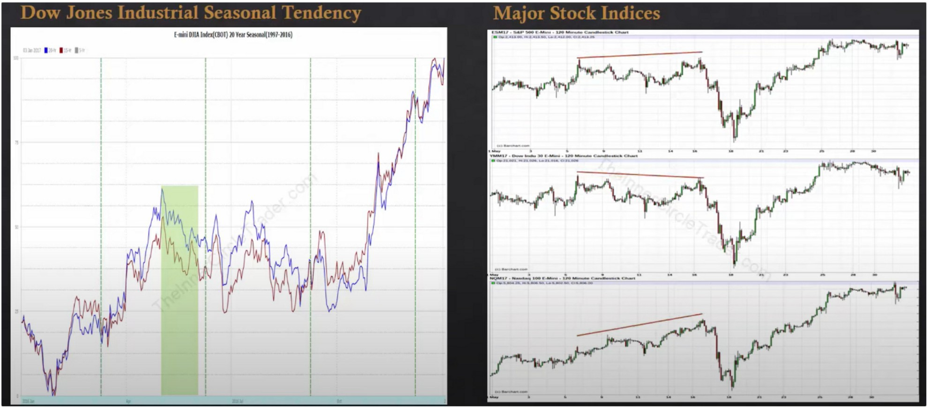

May

If youre going to trade stocks, in ICT opinion its better to focus on times where the market is predisposed to go higher and not be such a bubble

As an investor in stocks you still need to be a trader, theres time where you want to be in stocks and times you want to be out of stocks

Focus on the sweet spots for investing in stocks

Arjo I Twitter, lnstagram I Linktree

Linktree. Make your link do more. https://l.co/HhmmTN1fUI

JavaScript is not available.

https://twitter.com/arjoio